PROBLEM 4 MATLAB

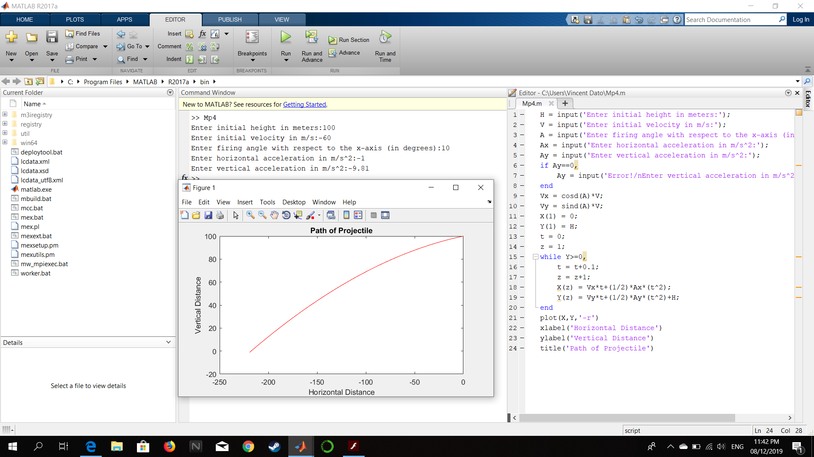

Figure : Screenshot of code and output

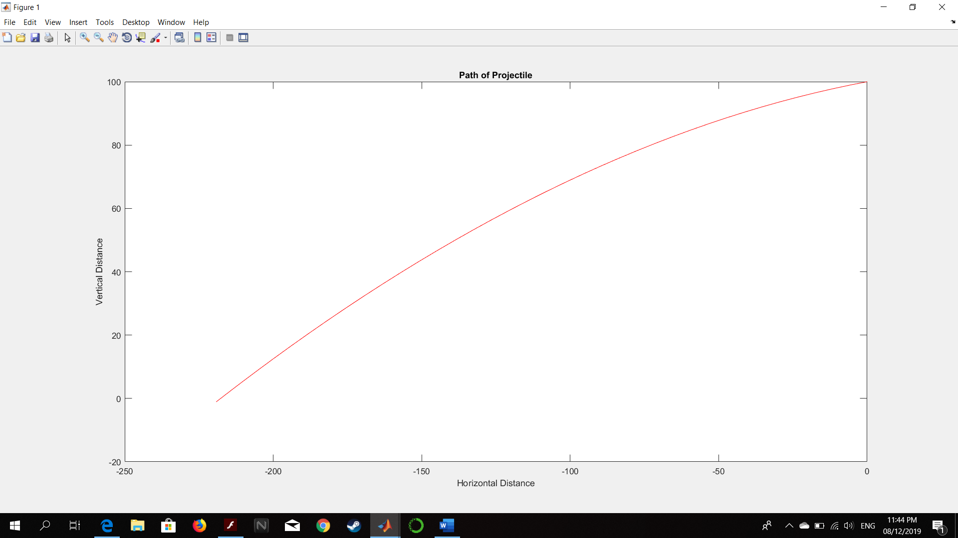

Figure :Successful output

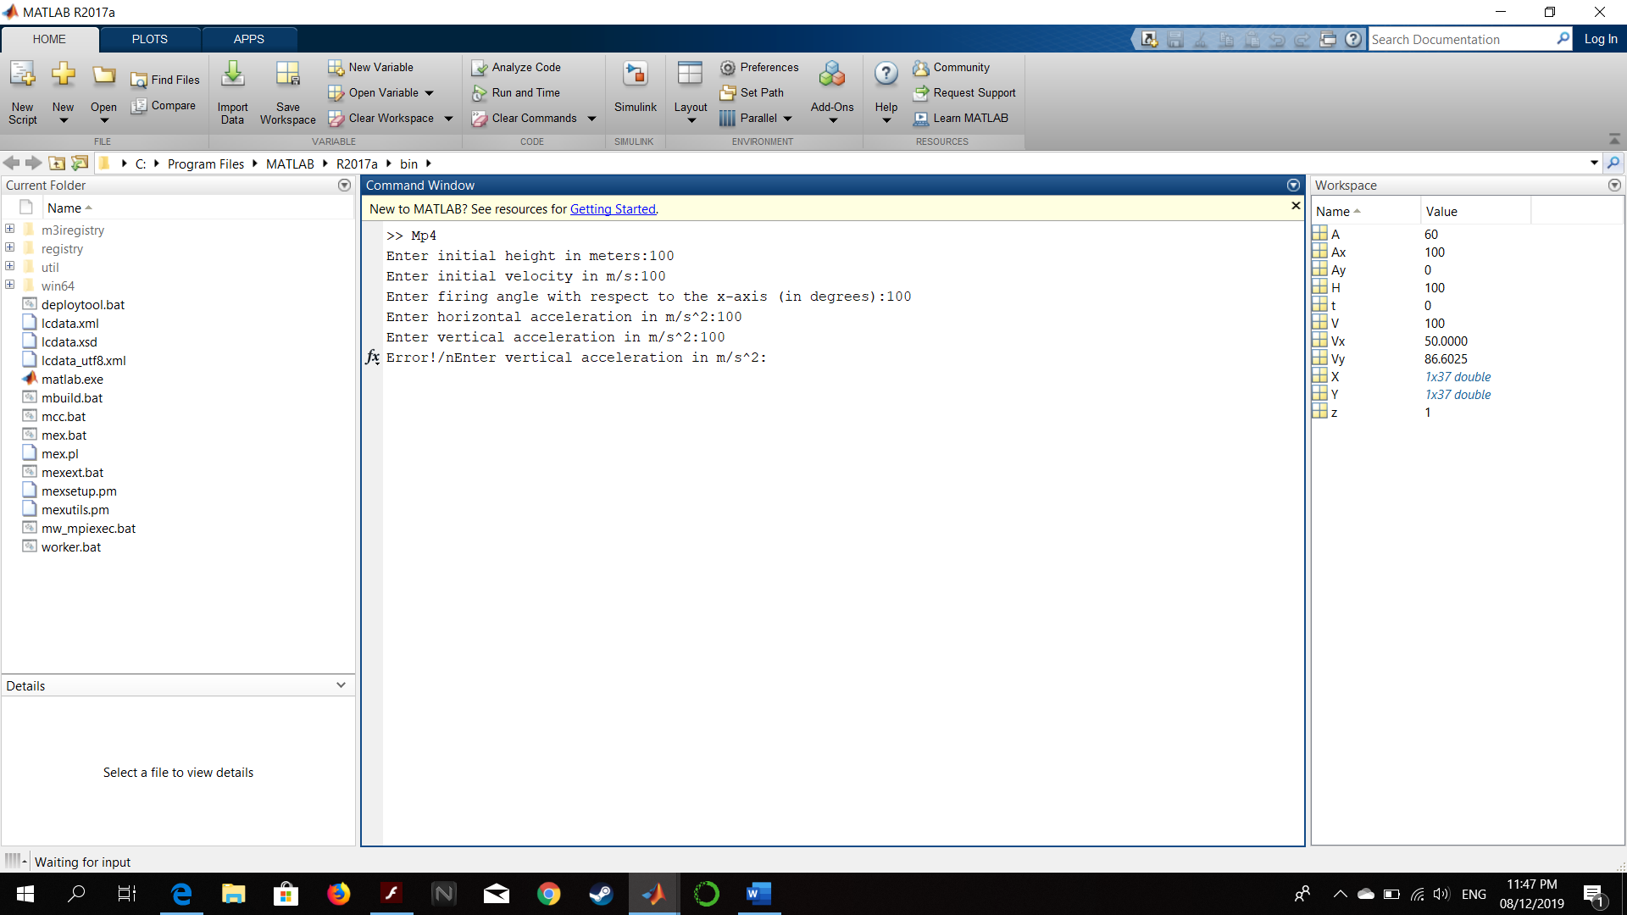

Figure : Error Prompt